Jose Martinez

Bio 447 Research Article

Dr. Newman, Dr. Morrison

**Title**: Assertion of motor-behavior abnormalities in *Drosophila CASK* mosaics

**Abstract**

Repetitive behaviors, such as grooming, are commonly linked to human neurodevelopmental disorders such as Fragile X syndrome (FSX) (Oakes A. *et al.,* 2016). *Drosophila* melanogaster has been previously used in studies to learn about neurodevelopmental disorders. *Drosophila* CASK (calcium/calmodulin-dependent serine protein kinase) lines display repetitive behavior such as consistently elevated grooming, despite their dramatic decrease in walking (Xingjie R. *et al.,* 2013). *Drosophila* CASK presents a loss of function (LOF) of the CASK gene, meaning they do not make the CASK protein, leading to increased grooming phenotype (Xingjie R. *et al.,* 2013). Repetitive behavior, such as excessive grooming, is a crucial subject for researching disorders like FXS. By studying *Drosophila* CASK lines, neurodevelopmental disorders in humans, such as FXS, can be better understood (Oakes A. *et al.,* 2016). In this study, the creation of knockout stocks, using the *Elav*>Cas9, *Mef2*>Cas9, gRNA CASK, and gRNA QUAS, will be used to study the relationship between the CASK gene and the nervous system. These stocks were created by crossing the Cas9/Gal4 lines, *Elav*>Cas9 and *Mef2*>Cas9, with either gRNA CASK or gRNA QUAS. If the CASK gene is working in the nervous system, then knocking out the expression of these genes in all neurons during all phases of development will re-create the phenotype that we see in true null mutants. The *Elav* knockout stock and the control lines showed no statistical difference in the Grooming Index (GI), the number of grooming bouts, or the mean grooming bout length. The P-values for these parameters are 0.0859, 0.0469, and 0.7399, respectively. These numbers indicate that this experiment's results did not support the hypothesis that the CASK gene is working in the nervous system. In contrast, the *Mef2*>Cas9 x QUAS cross resulted in a recessive lethal cross.

**Background and Significance**

**Fragile X syndrome (FXS) and CASK:**

Mutations can cause neurodevelopmental disorders with abnormal motor behavior such as excessive grooming (Oakes *et al.,* 2016). Patients with Fragile X syndrome, the leading monogenetic cause of intellectual disability (ID) in humans, display repetitive behaviors (Oakes *et al.,* 2016). Repetitive behaviors in humans include insisting that specific things take place at a specific time, on walking in a particular pattern, or in sitting in the same place, and are indicative of intellectual disability (ID) such as FXS (Oakes *et al.,* 2016). These repetitive behaviors are also a key feature of autism (Oakes *et al.,* 2016). FXS is one of the most common causes of inherited ID. Children who display the phenotype of FXS do not make the protein FMRP (Oakes et al., 2016). The FMR1 gene encodes for FMRP protein that later binds to mRNA transcripts and functions as transport, translational repression, and metabolism. The inhibition of the FMR1 gene is due to a LOF mutation caused by a 200 CGG trinucleotide repetition in the upstream untranslated region of the gene (Willemsen *et al.,* 2011). Animals such as *Drosophila* also exhibit repetitive behaviors such asexcessive grooming. The term repetitive behaviors refers to a broad heterogeneous category of behaviors characterized by the repetition of unvarying movements or more simply stereotyped behaviors (Wolff *et al.,* 2012).

**CASK in *Drosophila:***

Drosophila CASK (calcium/calmodulin-dependent serine protein kinase) mutants display elevated levels of grooming when compared to wild type Drosophila (Küryet al., 2017). CASK regulates CAMK2B (Calcium/Calmodulin Dependent Protein Kinase II Beta) (Küry et al., 2017). A LOF in CAMK2B has been linked to ID; the LOF of CAM2B can be caused by CASK mutations (Küryet al., 2017). The protein levels of CAMK2B affects neuronal migration and neurodevelopment; this leads to ID in humans and excessive grooming in flies (Küry et al., 2017). The specific mechanism as to CAMK2B protein levels affects neuronal migration and neurodevelopment is still under study and not yet certain (Küry et al., 2017). The elevated repetitive behavior (excess grooming) in Drosophila CASK mutants showed that it was consistent with presentation common in FXS (Hsueh et al., 2006). As a result, CASK has been linked to ID in both humans and Drosophila (Hsueh et al., 2006).

Drosophila CASK lines display repetitive behavior such as consistently increased grooming (when fly legs rub against each other or sweep over the surface of the body and wings), in addition to their dramatically decreased walking phenotype (Xingjie et al., 2013). Grooming in Drosophila has been studied by comparing the amount of normalized average bout length and the total time spent grooming in the CASK Drosophila mutants compared to the wild type Drosophila (Slawson et al., 2011). The elevated grooming seen in Drosophila CASK lines can be studied to further understand neurodevelopmental disorders in humans such as FXS (Hsueh et al., 2006).

The Drosophila CASK gene encodes two families of proteins from two independent transcriptional start sites. One of the two families is the CASK-β proteins: these have a CaMK (Ca2+/calmodulin-dependent protein kinase) domain followed by L27's, PDZ (postsynaptic density protein), SH3 (SRC Homology 3), and a guanylate kinase domain (Slawson et al., 2011). The L27 domain is a portion interactions module that functions as an organization center of large protein assemblies; this is required to establish and maintain cell polarity (Slawson et al., 2011). The PDZ domain plays a key role in anchoring the LIM (tandem zinc-finger) domains of receptor proteins in the membrane to the actin and the cortical cytoskeleton components of the cell (Fanning et al., 1999). The SH3 domains mediate the assembly of specific protein complexes by binding to proline-rich sequences, particularly PPII (polyproline 2) conformation (Kurochkina et al., 2013). The other family of proteins is the CASK-α's, which have a short unique N-terminal sequence before the PDZ domains and lack the CaMK and L27 domains (Slawson et al., 2011). Most previous work on CASK's nervous system function has been conducted on trans-heterozygote deficient animals lacking the CASK (Slawson et al., 2011). These Drosophila lacking the CASK gene are infertile and have severe locomotor defects (Mukherjee et al., 2014).

**TRiP-KO and knockout fly stocks:**

Abnormal grooming behavior has been studied using knockout fly stocks (Slawson et al., 2011). Creating a knockout stock or inducing a gene knockout is a genetic technique in which an organism's genes are made inoperative. This technique can allow researchers to see how a gene influences the organism's phenotype. One of the methods to create knockout stocks is the TRiP-CRISPR knockout or the TRiP-KO (Poe *et al.,* 2019). The TRiP-KO works with CRISPR/Cas9 to create knockout lines. CRISPR is comprised of two parts: the Cas9, an enzyme that cuts DNA, and the sequence guide RNA that leads Cas9 to a specific location in the DNA where the edit should be made. Cas9 associated with the guide RNA allows us to target a specific site in the DNA (Poe *et al.,* 2019).

 When using the TRiP-KO protocol to target a specific gene, the process starts by using Cas9 to generate a double-stranded break at a genomic site, as seen in Figure 1. The double-stranded break location is specified by the single-guide RNA (sgRNA)/ the guide RNA. The DNA is then repaired via the cell's nonhomologous end joining repair mechanism (Austin *et al.,* 2004). A mechanism that introduces site specific insertions and deletions (indels) can effectively disrupt the gene's activity, as seen in Figure 1 (Harvard Medical School, n.d. ; Poe *et al.,* 2019). In this experiment, this was done by crossing the sgRNA *Drosophila* with the Gal4>Cas9 *Drosophila*, resulting in a frameshift, causing early termination, and either producing non-functional protein or nonsense mediated decay of the mRNA translation (Austin *et al.,* 2004). Often this will be seen as NHEJ and result in nonhomologous end joining, which then results in a LOF mutation.

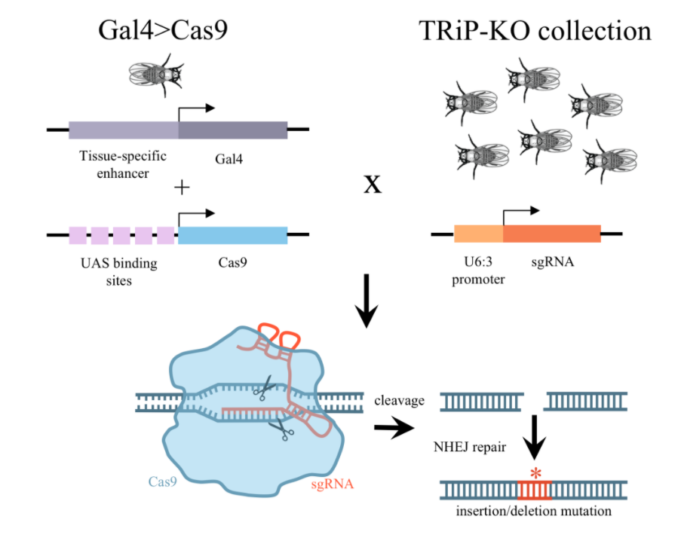

**Figure 1:** Shows how the TRiP-KO can generate indels in the genome by crossing to tissue-specific Gal4>Cas9 flies (Harvard Medical School, n.d.)

The Gal4 encodes a transcriptional activator protein (Gal4 ; Kawakami *et al.,* 2016). This gene is found in a fly genome placed under the control of a native enhancer. (Kawakami *et al.,* 2016). When the enhancer is active, Gal4 is expressed, but when the enhancer is inactive, Gal4 is not expressed; different enhancers are only active in specific tissues at specific times (Masso *et al.,* 2018 ; Kawakami *et al.,* 2016). The second part of this system is the Upstream Activation Sequence (UAS); UAS is the enhancer that binds to Gal4 and promotes the transcription of the gene of interest, the reporter (Masso *et al.,* 2018). These two systems start in separate fly lines, one being the Gal4 driver line and the other line being the reporter line (Masso *et al.,* 2018 ; Kawakami *et al.,* 2016). Crossing these two lines produces progeny that contain both the Gal4 gene and the reporter gene; in these flies, the Gal4 will only be expressed in a tissue of choice where the native enhancer is active (Masso *et al.,* 2018 ; Kawakami *et al.,* 2016). In the cells where Gal4 protein is expressed. The Gal4 protein will bind to the UAS, thus triggering the reporter gene's expression (Masso *et al.,* 2018).

The Cas9/Gal4 lines that we used in this experiment are *Elav*>Cas9 and *Mef2*>Cas9. The *Elav*>Cas9 gene is expressed in all neuronal cells; the *Elav*>Cas9 promoter's expression begins in embryonic nervous systems (Pathak *et al.,* 2017). *Mef2*>Cas9 is only expressed in muscle cells; the *Mef2*>Cas9 is expressed within the mesoderm's neurons (University of Bloomington n.d. ; Pathak *et al.,* 2017).

**Previous Studies with CASK:**

Slawson *et al.* used the TRiP-KO method to create knockout stocks of *Drosophila* with a LOF mutation in the CASK gene. This method allowed them to study how the CASK gene affects *Drosophila* behavior. The Slawson *et al.* experiment is the first-ever experiment to describe the CASK gene's phenotypic role in *Drosophila* accurately. There is significant overlap between their research and ours. Thus, this experiment could be considered an extension of the Slawson *et al.* experiment. The main difference between Slawson *et al.* and this experiment is that Slawson *et al.* produced a total knockout of expression of the CASK gene in *Drosophila* through all of the development. In contrast, this experiment created a knockout of CASK gene in specific neural cells or muscle cells of *Drosophila* throughout all of development. Doing this allows us to see if the CASK gene is working with the nervous system or not.

Slawson *et al.* showed that the CASK isoform containing CaMK-like and L27 domains increases grooming behavior despite the overall decrease in *Drosophila*'s movement. Slawson *et al.* did this by making four different crosses. Df(3R) x307 and Df(3R) x313 lines are CASK deficiency lines; they are both missing CASKβ and the CASKα domains. Both of these lines were used to make the first cross, thus making the 307/313 line.

Slawson *et al.* originally predicted that the 307/313 line, the CASK null line, would not contain the CASK- β nor the CASK –α isoform on any chromosome, thus making it impossible to make the CASK protein. The 307/313 cross represents a *Drosophila* line that lacks the majority of the CASK gene locus and thereby reduces the expression of the CASK protein (Slawson *et al.,* 2011). They checked for the expression of the CASK proteins via immunoblot/western blotting; the western blot did not show the CASK protein's presence in the 307/313, thus indicating that there was no expression of the CASK protein (Slawson *et al.,* 2011).

The other three lines that they crossed were rescue lines. For rescue lines, Gal4 driver lines C155-Gal4, C164-Gal4, and OK371-Gal4 were each individually crossed into the CASK-beta and alpha null background (Slawson *et al.,* 2011). The C164-Gal4 driver can drive the expressions of genes in a subset of CNS neurons (Slawson *et al.,* 2011). The OK371-Gal4 driver is an enhancer trap line that expresses strongly in both larval and adult motor neurons (Slawson *et al.,* 2011)*.* The C115-Gal4 drives the expression of the gene of interest in motor neurons in both larva and adults. Unfortunately, this gene of interest's expression tends to be weak in adulthood when using this driver (Slawson *et al.,* 2011).

Slawson *et al.* made these rescue lines to try to restore the lost gene from the knockout line (307/313). The 307/313 line had abnormal locomotor behavior: they groomed more despite having less locomotion movement than the wild type *Drosophila* (Slawson *et al.,* 2011). Slawson *et al.* also found that rescuing the CASK locus using the C164-Gal4 driver restored and improved *Drosophila*'s behavior. Slawson *et al.* found that the C164-Gal4 driver could make the CASK mutant have the same phenotype as the wild-type *Drosophila*; however, KO371-GAL4 did not change the CASK phenotype in the flies. In contrast, the C115-Gal4 driver was able to create a slight decrease in the amount of grooming in the CASK flies, thus making them look somewhat like the wild type *Drosophila*. More specifically, Slawson *et al.* found that the C164-Gal4 driver had higher normalized average locomotor acceleration, higher average peak speed of locomotion, higher bout length, and decreased initial pause length of locomotion.

The KO371-Gal4 did not rescue any of the four parameters tested (normalized average acceleration of locomotion, the peak speed of locomotion, bout length, initial pause length of locomotion ; Slawson *et al.,* 2011). The C115-Gal4 partially rescued these four parameters by increasing the normalized average. Acceleration normalized average peak speed of locomotion, normalized average bout length, and normalized average initial pause length of locomotion (Slawson *et al.,* 2011)*.*

Abnormal grooming behavior has been found consistently in animal models of FXS. The CASK mutants *Drosophila* have been linked to abnormal grooming patterns. Creating a knockout expression of the CASK gene in neuronal cells throughout all of development will test the hypothesis that the CASK gene is working in the nervous system. Additionally, it may help determine whether doing so can cause an increase in grooming in *Drosophila*. Furthermore, it will allow one to understand better the expression of the CASK protein and how the CASK gene relates to FXS. We hypothesize that if the CASK gene is working within the nervous system and causes abnormal grooming behaviors in *Drosophila*, then knocking out the expression of these genes in all neurons during all phases of development will re-create the altered grooming phenotype seen in null mutants.

**Materials and Methods**

**Fly strains:**

All fly lines *Elav*>Cas9, *Mef2*>Cas9, CASK gRNA, and QUAS gRNA were obtained from the University of Bloomington stock center. Once the fly strains were obtained, they were maintained throughout the experiment. Unfortunately, due to time constraints, the validations of the line to make sure that flies arrived from the correct stock, were not done. The lines were maintained in narrow *Drosophila* vials (made of polystyrene with a diameter of 2mm a height of 95mm) containing 8.5g of Nutri-FlyTM BF food; the food was obtained from Genesee Scientific, San Diego, CA. The flies were kept in an incubator at 25o Celsius with a humidity of 75%, with a circadian rhythm of 12 hour light, 12 hour dark cycle. The lines were expanded every Monday, Wednesday, and Friday at 10:00 am EST. The lines were expanded by transferring the files from the newest vial and transferring them over to a new vial; each vial was labeled with the date on which adult flies were introduced to the said vial; the expanding of the lines was done using the flipping technique (Andrew *et al.,* 2020 ; Hannum 2017). The expanding of the lines was done to have a bigger population of flies to make the crosses.

**Knockout crosses:**

To prepare the experimental crosses (*Elav*-*Gal4*; *UAS*-*Cas9* x *Drosophila CASK*, *Mef2*>Cas9 x *Drosophila CASK*), 18 female virgins from the *Elav*>Cas9 and the *Mef2*>Cas9 were collected; 72 males from *Drosophila CASK* were also collected. The Mosaic (TRiP-KO) protocol was used to cross them. Virgin female flies were selected to make sure that the females were not carrying any unwanted progeny eggs. This protocol is a two-step process (Poe *et al.,* 2019). The first step is collecting female virgins from the *Elav*>Cas9 and the *Mef2*>Cas9 lines. Six female virgins from the *Elav*>Cas9 and six female virgins *Mef2*>Cas9 were placed into two separate vials. Then, nine male *CASK* gRNA Drosophila (y1 sc1 v1 sev21; *CASK*-gRNA;+) were placed into each of the vials with the female virgins of *Elav*>Cas9 or *Mef2*>Cas9; this process was repeated two more times for both crosses (*Elav*>Cas9 x *CASK* gRNA and *Mef2*>Cas9 x *CASK* gRNA). Once this was done, both stocks were expanded and the pupae from said stocks were collected and placed into individual vials (one pupa was placed per 14mL test tube, 16*100mm with about 30 mL of agar food). The time when the pupae/progeny were collected and the time when they eclose, emerged from their pupae cases, was written down in the lab notebook. Tables 1 and 2 display both experimental crosses with the Cyo (Curly of Oster) balancer used. The Cyo gene is present in the *Drosophila* displayed curly wings phenotype (Pina *et al.,* 2000).

The balancer gene allows for the selection against the progeny that do not contain the genes needed for the execution of this experiment. Balancers are used to maintain deleterious mutations, CASK mutation, in a specific fly population.The balancer gene works in three distinct ways. One of them is by making the balancer gene, Cyo, homozygous, a lethal gene, meaning that a fly that carried d two alleles of the balancer die off. Second, using the balancer as a dominant maker implies that one can easily pick out the flies with the genotype of interest by looking at them (Pina *et al.,* 2000). Lastly, the balancer gene works by preventing multiple alleles on the same chromosome from being separated by recombination (Pina *et al.,* 2000). Balancers do this via numerous nested inversions; numerous portions of the chromosome have been reversed due to the chromosome breaking and rearranging itself. This property prevents recombination between the balancer and mutated chromosome, thereby keeping mutation on the original chromosome (Pina *et al.,* 2000).

**Negative control crosses:**

The process of making the control crosses, *Elav*-*Gal4*; *UAS*-*Cas9* x *Drosophila QUAS*, *Mef2*>Cas9 x *Drosophila* *QUAS,*followed the same method as the experimental crosses, but instead of using the sgRNA CASK line, the sgRNA QUAS was be used. Tables 3 and 4 display both negative control crosses (University of Bloomington n.d. ; Pathak *et al.,* 2017).

Table 1 and Table 2 show the displays of the two possible crosses that could have been completed. In Table 1, we see the Punnett square showing the *Elav*>Cas9 x RNA CASK, where the *Elav*>Cas9 line are virgin females, and the CASK line are males. Table 1 displays how two of the progeny *Drosophila* contain the *Elav*-Gal4, UAS-Cas9, and the CASK gRNA gene needed for the knockout expression of the CASK gene entire nervous system. The other two progeny contained the *Elav*-Gal4; Cyo flies do not have the UAS-Cas9 gene needed to produce the knockout expression of the CASK gene. The Cyo gene expresses the Curly of Oster balancer; this balancer is a dominant maker that can be seen phenotypically in the flies' wings (Pina *et al.,* 2000).

The flies with curly wings have Cyo, the balancer gene, meaning that they did not have the genotype needed for this experiment. This is why the *Drosophila* with the curly wings containing the Cyo were selected against. In the Table 1 Punnett square, half of the flies contained the genes needed to create a knockout expression, while the other half contained the Cyo gene, meaning they were heterozygotes and did not contain the genotype required for the experiment. In this case, they did not contain the UAS-Cas9 gene.

In contrast, in Table 2, we see the Punnett square for *Elav*>Cas9 male flies when crossed with female virgin CASK gRNA flies. Here, four of the progeny types present in the Punnett square do not contain the *Elav*-Gal4, UAS-Cas9, and the CASK gRNA gene are needed to create a knockout expression of the CASK gene. Only one out of four progeny in the Punnett square in Table 2 has *Elav*-Gal4, UAS-Cas9, and the CASK gRNA gene, the genes we sought out to recreate a knockout expression of the CASK gene. If the progeny flies did not have *Elav*-Gal4, UAS-Cas9, and the CASK gRNA genes, we did not use them to record their phenotypic behavior, which means that only one-fourth of the flies in the cross contained the genes needed to create the knockout expression of the CASK gene. The other three progeny were missing one of the three other genes: *Elav*-Gal4, UAS-Cas9, or the CASK gRNA gene. These progeny could be distinguished by using the Cyo, the balancer gene, that makes the flies’ wings curly. The males in the cross do not have the genotype needed for this experiment. This same scenario occurs when using either CASK gRNA females or gRNA QUAS females to be crossed with either *Elav*>Cas9 males or *Mef2*>Cas9 males (Tables 4, 6, 8).

The same circumstance that happens in Table 2 presents itself in Tables 4, 6, and 8; the *Mef2*>Cas9 males cross with the QUAS females, the *Elav*>Cas9 males crossed with the QUAS females, and the *Mef2*>Cas9 males crossed with the QUAS female, respectively. In these tables, there is only one out of four progeny in the Punnett square that has the genes of interest, *Elav*-Gal4, UAS-Cas9, and the CASK gRNA gene. The other three progeny are missing either the *Elav*-Gal4, UAS-Cas9, or the CASK gRNA gene and instead contain the Cyo balancer gene; the males in this cross are not going to have the genotype needed for this experiment. Therefore, the males and the flies with curly wings will not be used if we were where to make these crosses.

Conversely, Tables 3, 5, and 7 show the reciprocal cross of Tables 4, 6, and 8. Tables 3, 5, and 7 show the Punnett squares for *Mef2*>Cas9 females crosses with the QUAS males, the *Elav*>Cas9 females crossed with the QUAS males, and the *Mef2*>Cas9 females crosses with the QUAS males, respectively. In these crosses, we see the same outcomes we saw in Table 1, which means that Tables 3, 5, and 7 displays two of the progeny *Drosophila* containing the *Elav*-Gal4, UAS-Cas9, and the CASK gRNA gene needed for the knockout expression of the CASK gene in the entire nervous system. The other two progeny contained the *Elav*-Gal4; Cyo, these flies do not have the UAS-Cas9 gene needed to produce the knockout expression of the CASK gene, and therefore, we will not be using the Cyo flies from this cross. Tables 1, 3, 5, and 7 give a higher number of progeny that contained the genes needed for the completion of this experiment than the reciprocal crosses. Therefore, the crosses used in this experiment are displayed in Tables 1, 3, 5, and 7; for this reason, virgin females from the specific driver line, *Elav*>Cas9 or *Mef2*>Cas9, will be used to cross with males from the CASK and the QUAS lines. No positive control was not made, which is a necessary control, due to complications in the semester and the complicated nature of making a positive control cross.

Table 1. *Elav*>Cas9 virgin females crossed with *Drosophila* CASK males

|  |  |  |
| --- | --- | --- |
|  | y1 sc1 v1 sev21; *CASK* gRNA;+ | >; CASK gRNA |
| *Elav*-Gal4; UAS-Cas9 | $$\frac{Elav-gal4}{y1 sc1 v1 sev21};\frac{UAS-CAS9}{CASKgRNA}$$ | $$\frac{Elav-gal4}{>};\frac{UAS-CAS9}{CASK gRNA}$$ |
| *Elav*-Gal4; Cyo | $$\frac{Elav-gal4}{y1 sc1 v1 sev21};\frac{CASK gRNA}{Cyo}$$ | $$\frac{Elav-gal4}{>};\frac{CASK gRNA}{Cyo}$$ |

Table 2. Male Elav>Cas9 flies crossed with female virgin CASK gRNA flies

|  |  |
| --- | --- |
|  | y1 sc1 v1 sev21; *CASK* gRNA;+ |
| *Elav*-Gal4; UAS-Cas9 | $$\frac{Elav-gal4}{y1 sc1 v1 sev21};\frac{UAS-CAS9}{CASKgRNA}$$ |
| *Elav*-Gal4; Cyo | $$\frac{Elav-gal4}{y1 sc1 v1 sev21};\frac{CASK gRNA}{Cyo}$$ |
| Y; UAS-Cas9 | $$\frac{Y}{y1 sc1 v1 sev21};\frac{CASK gRNA}{UAS-CAS9}$$ |
| Y; CyO | $$\frac{Y}{y1 sc1 v1 sev21};\frac{CASK gRNA}{Cyo}$$ |

Table 3. *Mef2*>Cas9 virgin females crossed with the *Drosophila* CASK males

|  |  |  |
| --- | --- | --- |
|  | y1 sc1 v1 sev21; *CASK* gRNA;+ | >; CASK gRNA |
| UAS-Cas9;Mef-Gal4 | $$\frac{UAS-Cas9}{y1 sc1 v1 sev21};\frac{Mef-Gal4}{CASKgRNA}$$ | $$\frac{UAS-Cas9}{>};\frac{Mef-Gal4}{CASK gRNA}$$ |
| Cyo; TM6B,Tb | $$\frac{Cyo}{y1 sc1 v1 sev21};\frac{TM6B,Tb}{CASK gRNA}$$ | $$\frac{Cyo}{>};\frac{TM6B,Tb}{CASK gRNA}$$ |

Table 4. *Mef2*>Cas9 males crossed with *Drosophila* CASK virgin females

|  |  |
| --- | --- |
|  | y1 sc1 v1 sev21; *CASK* gRNA;+ |
| UAS-Cas9;Mef-Gal4 | $$\frac{UAS-Cas9}{y1 sc1 v1 sev21};\frac{Mef-Gal4}{CASKgRNA}$$ |
| Cyo; TM6B,Tb | $$\frac{Cyo}{y1 sc1 v1 sev21};\frac{TM6B,Tb}{CASK gRNA}$$ |
| Y; UAS-Cas9 | $$\frac{Y}{y1 sc1 v1 sev21};\frac{CASK gRNA}{UAS-CAS9}$$ |
| Y; CyO | $$\frac{Y}{y1 sc1 v1 sev21};\frac{CASK gRNA}{Cyo}$$ |

Table 5. *Elav*>Cas9 virgin females crossed with *Drosophila* QUAS gRNA males

|  |  |  |
| --- | --- | --- |
|  | y1 sc1 v1 sev21 ; QUAS-gRNA | >; QUAS-gRNA |
| *Elav*-Gal4; UAS-Cas9 | $$\frac{Elav-gal4}{y1 sc1 v1 sev21};\frac{UAS-CAS9}{QUAS-gRNA}$$ | $$\frac{Elav-gal4}{>};\frac{UAS-CAS9}{QUAS-gRNA}$$ |
| *Elav*-Gal4; Cyo | $$\frac{Elav-gal4}{y1 sc1 v1 sev21};\frac{UAS-CAS9}{Cyo}$$ | $$\frac{Elav-gal4}{>};\frac{CASK gRNA}{Cyo}$$ |

Table 6. *Elav*>Cas9 males crossed with *Drosophila* QUAS gRNA female virgins.

|  |  |
| --- | --- |
|  | y1 sc1 v1 sev21 ; QUAS-gRNA |
| *Elav*-Gal4; UAS-Cas9 | $$\frac{Elav-gal4}{y1 sc1 v1 sev21};\frac{UAS-CAS9}{QUAS-gRNA}$$ |
| *Elav*-Gal4; Cyo | $$\frac{Elav-gal4}{y1 sc1 v1 sev21};\frac{UAS-CAS9}{Cyo}$$ |
| Y; UAS-Cas9 | $$\frac{Y}{y1 sc1 v1 sev21};\frac{CASK gRNA}{UAS-CAS9}$$ |
| Y; CyO | $$\frac{Y}{y1 sc1 v1 sev21};\frac{CASK gRNA}{Cyo}$$ |

Table 7. *Mef2*>Cas9 virgin females with *Drosophila* QUAS gRNA males

|  |  |  |
| --- | --- | --- |
|  | y1 sc1 v1 sev21 ; QUAS-gRNA | >; QUAS-gRNA |
| UAS-Cas9;Mef-Gal4 | $$\frac{UAS-Cas9}{y1 sc1 v1 sev21};\frac{Mef-Gal4}{QUAS-gRNA}$$ | $$\frac{UAS-Cas9}{>};\frac{Mef-Gal4}{QUAS-gRNA}$$ |
| Cyo; TM6B,Tb | $$\frac{Cyo}{y1 sc1 v1 sev21};\frac{TM6B,Tb}{QUAS-gRNA}$$ | $$\frac{Cyo}{>};\frac{TM6B,Tb}{QUAS-gRNA}$$ |

Table 8. *Mef2*>Cas9 males crossed with *Drosophila* QUAS gRNA female virgins

|  |  |
| --- | --- |
|  | y1 sc1 v1 sev21 ; QUAS-gRNA |
| UAS-Cas9;Mef-Gal4 | $$\frac{UAS-Cas9}{y1 sc1 v1 sev21};\frac{Mef-Gal4}{QUAS-gRNA}$$ |
| Cyo; TM6B,Tb | $$\frac{Cyo}{y1 sc1 v1 sev21};\frac{TM6B,Tb}{QUAS-gRNA}$$ |
| Y; UAS-Cas9 | $$\frac{Y}{y1 sc1 v1 sev21};\frac{CASK gRNA}{UAS-CAS9}$$ |
| Y; Cyo | $$\frac{Y}{y1 sc1 v1 sev21};\frac{CASK gRNA}{Cyo}$$ |

**Collection and monitoring of Knockout and Negative control crosses:**

The pupae were collected from the *Elav*-*Gal4*; *UAS*-*Cas9* x *Drosophila CASK*, and *Mef2*>Cas9 x *Drosophila CASK* crosses. Once collected, each pupa was placed into an individual vial. The vial was a 16x100mm sterile culture tube with 2g of Nutri-FlyTM BF food; the food and vials were obtained from Genesee Scientific company located in San Diego, CA. The vial was then labeled with the date and an assigned number. The date, collection time, line, and sex were all recorded in the monitoring log. Afterward, the vials containing the pupae were placed in the incubator with a temperature of 25o Celsius and humidity around 75%. The tubes containing the pupae were monitored every day at 8 in the morning and at 3 in the afternoon to see at what time they eclosed, or emerged from their pupa cases. Once the flies had gained a maturity of 24-28 hours old after eclosion, they were ready for video recording. The reason for this is because it allows us to ensure that the nervous system had fully matured; this is also when the CASK *Drosophila* displays pronounced symptoms of repetitive behavior (Andrew *et al.,* 2020). It should be mentioned that flies with physical abnormalities that compromised their movement or behavior, such as broken legs or wings failing to unfurl were not used to record and collect data for this study.

**Locomotor analysis:**

Once the progeny from the respective crosses were 24-28 hours old, they were analyzed by placing individual animals per well in a 96 well plate. Afterward, the flies were kept in the 96 well holes by putting a coverslip on top of the hole where the flies receded. The flies were left for two hours in the room in which they were going to be recorded to let them acclimate to the environment. After the appropriate amount of time had passed, the flies were recorded for ten minutes to see how often each of the crosses displayed repetitive behavior, such as consistently grooming despite their dramatically decreased walking phenotype. The progeny were placed in the 96 well plates by a suction tube; this suction tube will transfer the progeny from their vials without putting them under anesthesia. Placing the flies under anesthesia or CO2 can alter the behavior and fitness, thus skewing the data results when recording the flies. Each well of the 96 well plates had a top internal diameter of 6.85 mm, a bottom inner diameter of 6.35 mm, and a depth of 10.76 mm; these dimensions can be found on the Matek life science website: https://www.mattek.com/products/multi-well-plates/. The 96 well plates had 200 µL of 1.5% agar per well in the plate. The reason for this is that the agar floor limited the depth of the arena while at the same time helping to maintain high humidity in the perimeter (Andrew *et al.,* 2020).

The periods of grooming bouts were recorded and observed before later transformation into quantifiable data. The video files were backed up on an external hard drive, a Dropbox account, and a work computer. These videos were recorded, for ten minutes per fly, with a VIXIA HF R82 camera (60 fps) in a room with a relative temperature of 25⁰ Celsius and a humidity of 47%. Once recorded, the videos were condensed using Open Adobe Premiere Pro CC 2015. These videos were scored manually using the open-source video-annotation software V-Code to generate continuous activity timelines, which were later represented graphically and quantitatively (Hagedorn *et al.,* 2008 ; Hannum 2017). When scoring the videos, each fly had a corresponding key, and whenever a fly started grooming, the key corresponding to that fly was pressed. The same key was pressed when the fly stopped grooming; this marked the beginnings and ends of a grooming bout, thus allowing for quantification of the amount of time spent grooming by each fly. For this experiment, grooming in *Drosophila* was defined as the act of rubbing/stroking head, antennae, proboscis, limbs, wings, or thorax using one or more limbs. The start of grooming behavior began when one of the limbs was used/first lifted from the fly’s resting position; the grooming behavior stopped when the limb used to groom returned to its resting position or was placed back into the ground. It should be clarified that grooming was not categorized by separate body parts groomed. Regardless of how many body parts were groomed in one bout, it was acknowledged as grooming.

**Statistical analyses:**

The data were extracted for V-code using custom, in-house Perl scripts (Andrew *et al.,* 2020 ; Hannum 2017). This script will be extracting the amount of time each fly spent grooming, the number of grooming bouts, and the average GI during the 10-minute video (this is the grooming index). Once this data was collected, it was represented in an Excel sheet where graph construction and statistical analysis were accomplished. Using this data in Excel, box plots will be constructed demonstrating the GI, mean number of grooming bouts, and mean grooming bout length. This data was used to perform a Wilcoxon Rank Sum test (p< 0.05) to compare the experimental values to the control values. Furthermore, a box plot was used to compare these three parameters between the control and experimental lines. This was done to determine the statistical significance between the control and the experimental lines (0< 0.05).

**Results**

***Mef2*>Cas9 x QUAS necrotic pupa:**

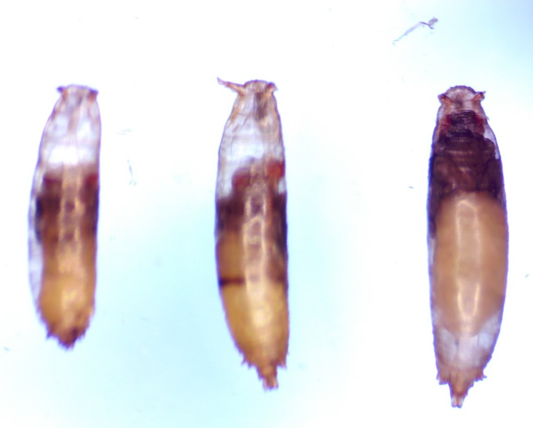

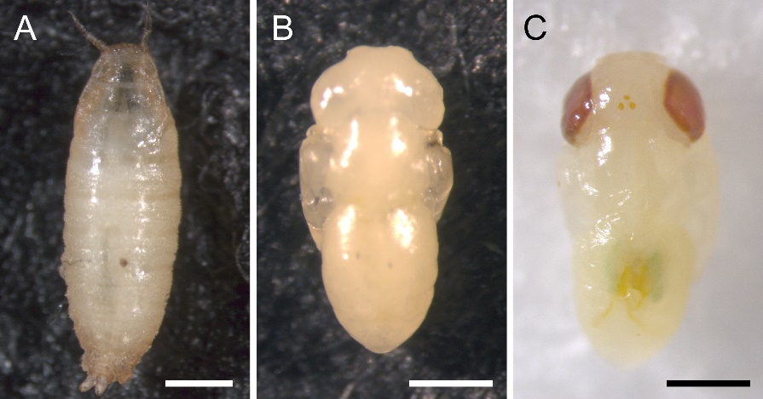

Figure 1 The left pupa is the progeny from the Mef2>Cas9 x QUAS line; this progeny developed necrotic tissue, after one day, and did not mature pass the pupa stage. Right pupa is healthy, this pupa is one day old (Fukutomi,et al., 2018); the picture of the pupae on the left can be found JoVE journal website: https://www.jove.com/t/56935/methods-for-staging-pupal-periods-measurement-wing-pigmentation.

The left pupa in Figure 1 shows necrotic pupae from the *Mef2*>Cas9 x QUAS line. This cross resulted in necrosis to 51% of the pupae in the vials. From the 35 flies of the *Mef2*>Cas9 x QUAS cross, 18 flies did not mature out of the pupa stage (they were necrotic/dead) and 17 were eclosed (they matured out of the pupa stage). This behavior was not seen in any of the other crosses (Figure 1). Due to this inconvenience, only four *Mef2*>Cas9 x QUAS flies were collected, two males and two females (Figure 1). In contrast the right pupa in Figure 1 show a 1-day old pupa with no necrotic tissue Fukutomi *et al.,* 2018).

**Ethograms:**

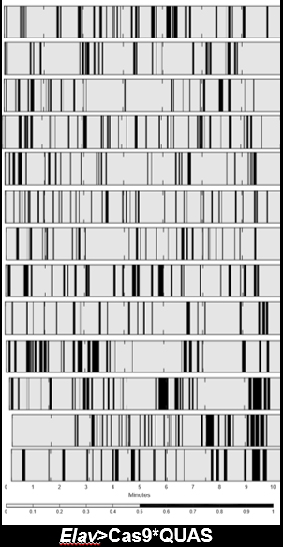

Figure 2 Ethograms from 13 individuals flies from the Elav>Cas9 x QUAS line. It should be noted that each row represents an individual fly’s behavior; the black color in the figure represents the time the fly spent grooming, while the grey portions of the figure represent the time the fly did not spend grooming though the 10 minute videos.

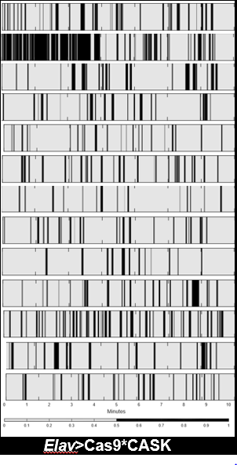

Figure 3 Ethograms from 13 individual flies from the Elav>Cas9 x CASK line. It should be noted that each row represents an individual fly’s behavior; the black color in the figure represents the time the fly spent grooming, while the grey portions of the figure represent the time the fly did not spend grooming though the 10 minute videos.

Recording of flies for 10 minutes was performed on a total of 45 individual flies; 17 of which were *Elav*>Cas9 x CASK (11 females and 6 males), 24 of them were *Elav*>Cas9 x QUAS (12 males and 12 females), and 4 were *Mef2*>Cas9 x QUAS (2 males and 2 females).

Differences in behavior of the two lines, the *Elav*>Cas9 x CASK line and the *Elav*>Cas9 x QUAS, can be visualized using ethograms (Figure 2 and 3). Each row of both Figures 2 and 3 represents the behavior of an individual fly within the 10-minute video recording. It should be noted the black portion in the Figure 2 and 3 represents the points in the video where the fly was grooming, while the grey portion of the figure represents any other behavior that is not grooming (Figure 2 and 3). In Figure 3, the second row shows a *Drosophila* *Elav*>Cas9 x CASK that groomed much more than the other flies from the respective line (Figure 2 and 3). This excessive grooming behavior, seen in the second row of Figure 3, was the behavior that was expected for all flies in the *Elav*>Cas9 x CASK, but was not presented in any of the other flies’ respective lines (Figure 2 and 3). With the exception of the second row from Figure 3, ethograms from both lines, *Drosophila* *Elav*>Cas9 x CASK and *Drosophila* *Elav*>Cas9 x QUAS, had the same amount of grooming behavior. This is supported by the ratio of grey and black presented in Figure 2 and 3 and further supported by Figures 4, 5, and 6.

Figure 4 Box plots of the values of number of grooming index values of the *Elav*>Cas9 x CASK and *Elav*>Cas9 x QUAS represented using Box-and-whisker plots. The blue box shows the 25th-75th percentiles; the red line in the box shows the median. The black lines, extending form the blue box, with the whiskers represent the 9th and the 91th. (p-value=0.0859). This box plot was constructed with 17 *Elav*>Cas9 x CASK (11 females and 6 males) and 24 *Elav*>Cas9 x QUAS (12 females and 12 males).

***Elav*>Cas9 x CASK and the *Elav*>Cas9 x QUAS Box-and-whisker plots:**

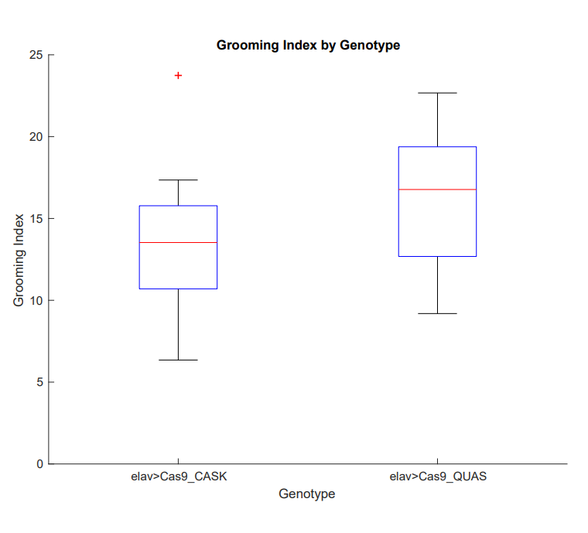

Three parameters were used to compare the behavior of the *Elav*>Cas9 x CASK line and the *Elav*>Cas9 x QUAS. The first parameter, grooming index, is the total percentage of time each fly spent grooming during the 10-minute video. The GI was compared for progeny flies from the *Elav*>Cas9 x CASK cross and progeny flies from the *Elav*>Cas9 x QUAS cross using the Wilcoxon Rank-Sum test and plotting the data using box and whisker plots (Figure 4). The *Drosophila* *Elav*>Cas9 x QUAS presented a slightly higher GI value than the *Drosophila* *Elav*>Cas9 x CASK. The Wilcoxon Rank-Sum test resulted in a p-value of 0.0859, suggesting that there is no significant difference in grooming index from progeny flies of both crosses (Figure 4).

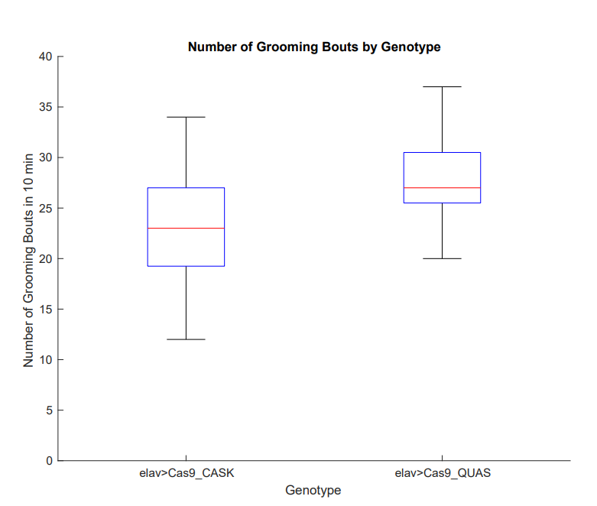

Figure 5 Box plots of the values of the number of grooming bouts done by Elav>Cas9 x CASK and Elav>Cas9 x QUAS represented using Box-and-whisker plots. The blue box shows the 25th-75th percentiles; in the red line in the box shows the median. The black lines, extending form the blue box, with the whiskers represents the 9th and the 91th. (p-value 0.0469). This box plot was constructed with 17 Elav>Cas9 x CASK (11 females and 6 males) and 24 Elav>Cas9 x QUAS (12 females and 12 males).

The second parameter, the number of grooming bouts, was compared between *Elav*>Cas9 x CASK line and the *Elav*>Cas9 x QUAS line using the Wilcoxon Rank sum test. A grooming bout was classified as a single period of grooming from start to stop.

The control line, *Drosophila* *Elav*>Cas9 x QUAS, presented with slightly higher number of grooming bouts than the experimental line, *Drosophila* *Elav*>Cas9 x CASK. However, the Wilcoxon Rank-Sum test resulted in a p-value of 0.0469 suggesting that it was not a statistically significant difference in the number of grooming bouts initiated by progeny flies between the two crosses (Figure 4).

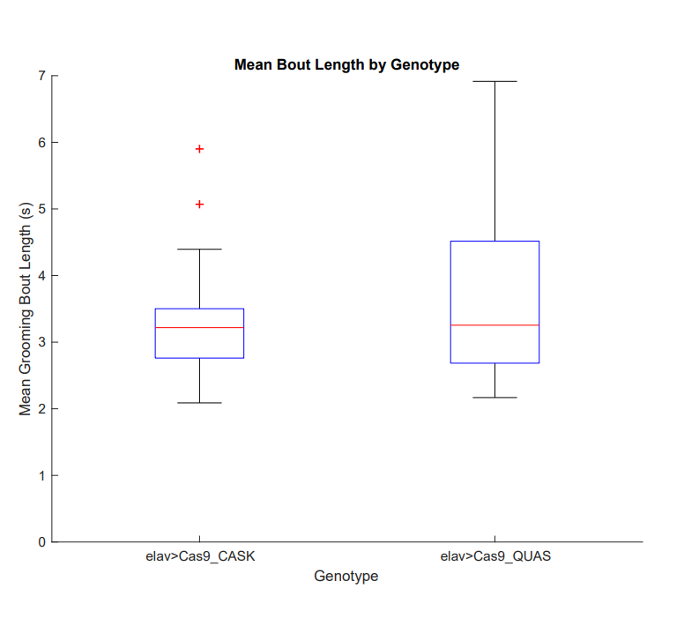

Figure 6 Box plots of the values of the mean bout length done by Elav>Cas9 x CASK and Elav>Cas9 x QUAS represented using Box-and-whisker plots. The blue box shows the 25th-75th percentiles; in the red line in the box shows the median. The black lines, extending form the blue box, with the whiskers represents the 9th and the 91th. (p-value=0.7399). This box plot was constructed with 17 Elav>Cas9 x CASK (11 females and 6 males) and 24 Elav>Cas9 x QUAS (12 females and 12 males).

The third parameter used to compare the grooming behavior of *Elav*>Cas9 x CASK cross flies and the *Elav*>Cas9 x QUAS cross flies was the length of each grooming bout (Figure 5). The control line, *Elav*>Cas9 x QUAS, showed a higher value of mean bout length than the experimental line *Elav*>Cas9 x CASK (Figure 5). Like the other parameters, a Wilcoxon Rank-Sum test was used to determine a statistically significant difference and the box and whisker plots were used to plot the data. Wilcoxon Rank-Sum test resulted in a p-value of 0.07399, suggesting that there is not a significant difference in the average grooming bout duration between flies from these two crosses (Figure 5).

***Mef2*>Cas9 x QUAS Box-and-whisker plots:**

Figure 7 Box plots of the values of number of grooming index values of the Mef2>Cas9 x QUAS represented using Box-and-whisker plots. The blue box shows the 25th-75th percentiles; in the red line in the box shows the median. The black lines, extending form the blue box, with the whiskers represents the 9th and the 91th. This box plot was constructed with 4 Mef2>Cas9 x QUAS (2 males and 2 females)

Figure 8 Box plots of the values of number of grooming bouts values of the Mef2>Cas9 x QUAS represented using Box-and-whisker plots. The blue box shows the 25th-75th percentiles; in the red line in the box shows the median. The black lines, extending form the blue box, with the whiskers represents the 9th and the 91th. This box plot was constructed with 4 Mef2>Cas9 x QUAS (2 males and 2 females)

The *Mef2*>Cas9 x QUAS, blistered>Cas9 x CASK, and Blistered>Cas9 x QUAS crosses were not able to be performed due to an insufficient number of collected flies and the time constraints of the semester. This was a result of ordering the flies three to four weeks into the semester, the time-consuming process of maintaining the crosses, and the collection of the adequate number virgin *Drosophila*.

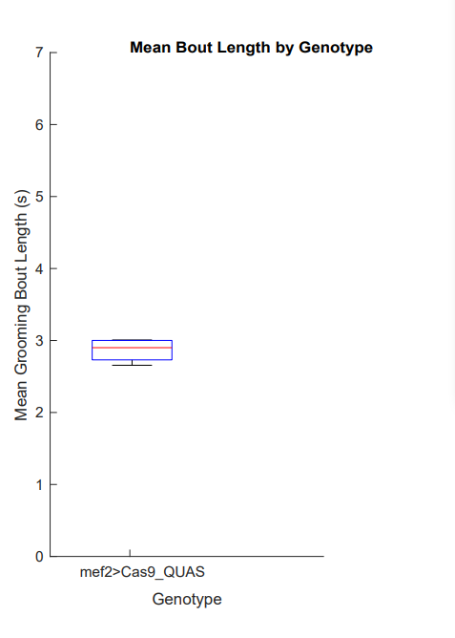Both the *Elav* control, *Elav*>Cas9 x QUAS, and the *Mef2* control, *Mef2*>Cas9 x QUAS, displayed different values for the GI (Figure 4 and 7). The GI for value for the *Elav* was higher than the value found in the *Mef2* control (Figure 4 and 7). Conversely, the number of grooming bout and the grooming bout length are relatively the same (Figure 5, 6, 8, and 9). The mean values for the number of grooming bout for both the *Elav*>Cas9 x QUAS and *Mef2*>Cas9 x QUAS are around 26; the mean value for grooming bout length for both *Elav*>Cas9 x QUAS and *Mef2*>Cas9 x QUAS was around 3 (Figure 5, 6, 8, and 9). The mean GI value for the *Elav* control was 18; the GI value for the *Mef2* control was 8 (Figure 4 and 7).

Figure 9 Box plots of the values of mean bout length values of the *Mef2*>Cas9 x QUAS represented using Box-and-whisker plots. The blue box shows the 25th-75th percentiles; in the red line in the box shows the median. The black lines, extending form the blue box, with the whiskers represents the 9th and the 91th. This box plot was constructed with 4 *Mef2*>Cas9 x QUAS (2 males and 2 females)

**Discussion**

**Necrotic tissue in *Mef2*:**

The reason why only four progeny flies (three males and one female) were recorded from the *Mef2*>Cas9 x QUAS should be noted. This is because many of the progeny flies did not mature out of the pupa stage. From the 35 flies of the *Mef2*>Cas9 x QUAS cross, 18 flies did not mature out of the pupa stage (they were necrotic/dead) and 17 were eclosed normally (they matured out of the pupa stage). The Cyo balancer gene dominant marker being selected against, in conjunction with the unforeseen circumstance of necrotic pupae, resulted in a significantly smaller number of flies than expected that could be collected from these crosses. This result was not seen in any of the other crosses. There is a possibility that the *Mef2*>Cas9 x QUAS cross produced a homozygous recessive lethal disease, resulting in the death of the fly in its pupal stage. At the time of writing, there is no literature that talks about the homozygous QUAS construct; according to the University of Bloomington stock center the QUAS is a non-targeting control sgRNA. Further studies need to be done to fully understand this cross. It is also possible that the lines from the Bloomington stock center were the wrong lines; therefore, the validation of these lines should be completed in future studies. The fly lines can be validated using a Polymerase chain reaction specific for the CASK gene, and samples of the gene can be sent out for sequencing to determine whether the Cas9 endonuclease excised portions of the CASK gene.

**Ethograms:**

Previous work has shown that the expression pattern of the CASK gene in *Drosophila* would lead to locomotor behavioral deficits such as excessive grooming. This study, unfortunately, has led to a different conclusion. Figure 1 and 2 ethograms show the same ratio in the amount of grey to black shading, meaning the amount of fly grooming and non-grooming behavior. However, there was an outlier: the second row of Figure 2 showed an *Elav*>Cas9 x CASK *Drosophila* experimental line exhibited an elevated level of grooming compared to the flies of the same line and the control line, *Elav*>Cas9 x QUAS. This was the expected behavior of all the members of *Elav*>Cas9 x CASK line; however, it did not translate to all of them (Figure 2). The overall ratio of the amount of grooming and non-grooming behaviors of both lines, the control and the experimental, was around the same amount (Figures 1 and 2). This can be seen graphically in box plots presented in Figures 4, 5, and 6; these box plots show the three parameters measured in this experiment (Figures 4, 5, and 6).

***Elav*>Cas9 x QUAS and *Elav*>Cas9 x CASK Box-and-whisker plots:**

The results of this experiment were unexpected for all three parameters. The *Elav*>Cas9 x QUAS, the control group, groomed more than the *Elav*>Cas9xCASK, the experimental group, but this difference was not significant according to the Wilson-Rank test (Figures 4, 5, and 6). Unfortunately, there was no significant correlation for any of the three tested parameters, GI, number of grooming bouts, and mean bout length (Figures 4, 5, and 6). Our results do not support the hypothesis that grooming behavior in *Drosophila* melanogaster is increased when the CASK undergoes a LOF mutation. Data from the V-code videos were extracted to an Excel sheet using custom in-house Perl Scripts; this data was then used to make Box and whisker plots, ethograms, and obtain p-values (using the Wilson rank-sum test) to quantify and analyze the grooming behavior on all three parameters (Figures 4, 5, and 6 ; Andrew *et al.,*  2020).

In the first parameter, the control group, *Elav*>Cas9 x QUAS, had higher GI than the *Elav*>Cas9 x CASK, but this difference was not statistically significant according to the Wilson-Rank test (Figure 4). The Wilson-Rank test, a nonparametric test, is the most appropriate because we were comparing the median of two related groups, the experimental *Elav* group and the control *Elav* group (Whitley *et al.,* F2002). The p-value generated when comparing GI between the *Elav*>Cas9 x CASK and the *Elav*>Cas9 x QUAS line was 0.0869, leading to the conclusion that there was no significant difference between these two lines (Figure 4). The second parameter, the number of grooming bouts, was higher in the control group, *Elav*>Cas9 x QUAS than in the *Elav*>Cas9 x CASK group, but this difference was also not statistically significant according to the Wilson-Rank test because it resulted in a p-value of 0.469 (Figure 5). The third parameter, the mean grooming bout length, showed that *Elav*>Cas9 x QUAS had a higher value than the *Elav*>Cas9 x CASK, but this difference was not statistically significant according to the Wilson-Rank test (Figure 6). Figure 6 suggested that there is no significant difference between the *Elav*>Cas9 x CASK and the *Elav*>Cas9 x QUAS cross flies (p-value=0.7399; Figure 6). These results do not support the hypothesis because the first, second, and third parameters showed no significant difference between the control line and the experimental line (Figures 4, 5, and 6).

There are four possible explanations for these findings from the *Elav*>Cas9 lines. The first is that that the *Elav*>Cas9 x CASK did not create true mosaics. This might be because the original fly lines that we obtained from the University of Bloomington stock center might not have had the genes necessary to create these mosaics, thus leading to the creation of the incorrect genotype. This can be confirmed by validating the cross progeny of the original lines that came from University of Bloomington stock center; the original are still present in the lab and can be tested in future projects, but the cross progeny whose behavior and data were collected have since been disposed of.

The second potential explanation is that the number of flies in the experimental and control groups were not equal; the control group had a total of 24 subjects while the experimental line had a total of 17 subjects (Figure 1). The unequal number of subjects can also help explain the inconsistencies in the data. The third possible explanation for this inconsistency is the possibility that the progeny flies of interest were reproducing with each other, meaning that the F1 generation was reproducing within each vial. This would create F2 progeny flies, which would not contain the genotype of interest. If any of the F2 progeny flies, lacking the genotype of interest, were selected for recording of data. This would have resulted in an inconsistency in the data.  The fourth explanation for this inconsistency is human error, meaning that it is possible that the vials were mislabeled. Mistaking the vials while transferring flies to breeding vials would have resulted in progeny that did not contain the correct genotype.

***Elav*>Cas9 x QUAS and *Mef2*>Cas9 x QUAS Box-and-whisker plots:**

Both the *Elav* control, *Elav*>Cas9 x QUAS, and the *Mef2* control, *Mef2*>Cas9 x QUAS, displayed different values for the GI and the mean bout length (Figures 4 and 7). The GI for value for the *Elav* was higher than the value found in the *Mef2* control (Figures 4 and 7). Conversely, the number of grooming bout and the grooming bout length are relatively the same (Figures 5, 6, 8, and 9). The GI value for the *Elav* control was 18; the GI value for the *Mef2* control was 8. The GI value was expected to be relatively the same in both the *Elav* control and the *Mef2* control, unfortunate this was not the case (Figures 4 and 7). The difference in GI values between the *Elav* control and the *Mef2* control can be explained with the same four explanations given above.

***Mef2*>Cas9 x QUAS, blistered>Cas9 x CASK, and Blistered>Cas9 x QUAS:**

The *Mef2*>Cas9 x QUAS, blistered>Cas9 x CASK, and Blistered>Cas9 x QUAS crosses were not able to be performed due to an insufficient number of collected flies and time constraints of the semester. This was a result of ordering the flies three to four weeks into the semester, the time-consuming process of maintaining the crosses, and the collection of the adequate number of virgins *Drosophila*.

**Future studies:**

For future studies, four crosses will be performed using the *Elav*>Cas9, Blistered>Cas9, gRNA CASK, and gRNA QUAS lines. It is important to note that the crosses will be done with the same methodology found in the methods section. This will result in four different crosses, with those crosses being *Elav*>Cas9 x CASK, Blistered>Cas9 x CASK, *Elav*>Cas9 x QUAS, and Blistered>Cas9 x QUAS. The negative control lines will be represented by the *Elav*>Cas9 x QUAS and Blistered>Cas9 x QUAS lines, while the experimental line will be represented by *Elav*>Cas9 x CASK, Blistered>Cas9 x CASK. For future studies, validations of the *Mef2*>Cas9, *Elav*>cas9, Blistered>Cas9, gRNA CASK, and the gRNA QUAS will be done prior to making the crosses to confirm that they are the correct lines needed for the experiment. Furthermore, a validation of the crosses after they are done, *Elav*>Cas9 x CASK, *Elav*>Cas9 x QUAS, Blistered>Cas9 x CASK, and Blistered>Cas9 x QUAS, will be performed once crosses are made to prove that the TRiP-KO protocol has worked and they are the KO lines that we want to work with. The validations of these lines will be done through genome analysis or by running a PCR for the CASK gene for cells in the corresponding tissue that was expected to have the knockout. The *Mef2*>Cas9 line will not be used for two main reasons. The first is time limitations caused by the crosses' maintenance, the collection of virgins, and the expansion. The second is the possibility of the Mef2>Cas9 x QUAS line resulting in a potential homozygous recessive lethal disease, killing ~51% of the flies in their pupal stage.

**Citations:**

Andrew, D. R., Moe, M. E., Chen, D., Tello, J. A., Doser, R. L., Conner, W. E., Ghuman, J. K., & Restifo, L. L. (2020). Spontaneous motor-behavior abnormalities in two *Drosophila* models of neurodevelopmental disorders. *Journal of neurogenetics*, 1–22. Advance online publication. <https://doi.org/10.1080/01677063.2020.1833005>

Austin, C. P., Battey, J. F., Bradley, A., Bucan, M., Capecchi, M., Collins, F. S., Dove, W. F., Duyk, G., Dymecki, S., Eppig, J. T., Grieder, F. B., Heintz, N., Hicks, G., Insel, T. R., Joyner, A., Koller, B. H., Lloyd, K. C., Magnuson, T., Moore, M. W., Nagy, A., … Zambrowicz, B. (2004). The knockout mouse project. *Nature genetics*, *36*(9), 921–924. <https://doi.org/10.1038/ng0904-921>

Cui, Y., Xu, J., Cheng, M., Liao, X., & Peng, S. (2018). Review of CRISPR/Cas9 sgRNA Design Tools. *Interdisciplinary sciences, computational life sciences*, *10*(2), 455– 465. <https://doi.org/10.1007/s12539-018-0298-z>

DRSC/TRiP functional genomics resources: Using TRiP-CRISPR lines. (n.d.). *Harvard Medical School*. <https://fgr.hms.harvard.edu/using-trip-crispr-lines>

Fanning, A. S., & Anderson, J. M. (1999). PDZ domains: fundamental building blocks in the organization of protein complexes at the plasma membrane. *The Journal of clinical investigation*, *103*(6), 767–772. <https://doi.org/10.1172/JCI6509>

Fukutomi, Y., Matsumoto, K., Funayama, N., Koshikawa, S. (2018).Methods for Staging Pupal Periods and Measurement of Wing Pigmentation. *Journal of Visualized Experiments 71*(131) 204-283. https://doi:10.3791/56935

Hannum C. L. (2017) Genetic Analysis of Spontaneous Grooming Behavior in the Fruit Fly *Drosophila Melanogaster. Unpublished.* Lycoming College Department Honors Thesis

Hsueh Y. P. (2006). The role of the MAGUK protein *CASK* in neural development and synaptic function. *Current medicinal chemistry*, *13*(16), 1915–1927. <https://doi.org/10.2174/092986706777585040>

Hsueh, Y. P., Wang, T. F., Yang, F. C., & Sheng, M. (2000). Nuclear translocation and transcription regulation by the membrane-associated guanylate kinase *CASK*/LIN-2.*Nature*, *404*(6775), 298–302. <https://doi.org/10.1038/35005118>

Kawakami, K., Asakawa, K., Hibi, M., Itoh, M., Muto, A., & Wada, H. (2016). Gal4 Driver Transgenic Zebrafish: Powerful Tools to Study Developmental Biology, Organogenesis, and Neuroscience. *Advances in genetics*, *95*, 65–87. <https://doi.org/10.1016/bs.adgen.2016.04.002>

Kurochkina, N., & Guha, U. (2013). SH3 domains: modules of protein-protein interactions. *Biophysical reviews*, *5*(1), 29–39. <https://doi.org/10.1007/s12551-> 012-0081-z

Küry, S., van Woerden, G. M., Besnard, T., Proietti Onori, M., Latypova, X., Towne, M. C., Cho, M. T., Prescott, T. E., Ploeg, M. A., Sanders, S., Stessman, H., Pujol, A., Distel, B., Robak, L. A., Bernstein, J. A., Denommé-Pichon, A. S., Lesca, G., Sellars, E. A., Berg, J., Carré, W., … Mercier, S. (2017). De Novo Mutations in Protein Kinase Genes CAMK2A and CAMK2B Cause Intellectual Disability. *American journal of human genetics*, *101*(5), 768–788. <https://doi.org/10.1016/j.ajhg.2017.10.003>

Masso, M., Rao, N., & Pyarasani, P. (2018). Modeling transcriptional activation changes to Gal4 variants via structure-based computational mutagenesis. *PeerJ*, *6*, e4844. https://doi.org/10.7717/peerj.4844

Mukherjee, K., Slawson, J. B., Christmann, B. L., & Griffith, L. C. (2014). Neuron- specific protein interactions of *Drosophila* CASK-β are revealed by mass spectrometry. *Frontiers in molecular neuroscience*, *7*, 58. <https://doi.org/10.3389/fnmol.2014.00058>

Oakes, A., Thurman, A. J., McDuffie, A., Bullard, L. M., Hagerman, R. J., & Abbeduto, L. (2016). Characterising repetitive behaviours in young boys with fragile X syndrome. *Journal of intellectual disability research: JIDR, 60*(1), 54–67. <https://doi.org/10.1111/jir.12234>

Pathak, T., Trivedi, D., & Hasan, G. (2017). CRISPR-Cas-Induced Mutants Identify a Requirement for dSTIM in Larval Dopaminergic Cells of *Drosophila melanogaster*. *G3 (Bethesda, Md.)*, *7*(3), 923–933. <https://doi.org/10.1534/g3.116.038539>

Pina, C., & Pignoni, F. (2012). Tubby-RFP balancers for developmental analysis: FM7c 2xTb-RFP, CyO 2xTb-RFP, and TM3 2xTb-RFP. *Genesis (New York, N.Y. : 2000)*, *50*(2), 119–123. <https://doi.org/10.1002/dvg.20801>

Poe, A. R., Wang, B., Sapar, M. L., Ji, H., Li, K., Onabajo, T., Fazliyeva, R., Gibbs, M., Qiu, Y., Hu, Y., & Han, C. (2019). Robust CRISPR/Cas9-Mediated Tissue- Specific Mutagenesis Reveals Gene Redundancy and Perdurance in *Drosophila*. *Genetics*, *211*(2), 459–472. <https://doi.org/10.1534/genetics.118.301736>

Port, F., Chen, H. M., Lee, T., & Bullock, S. L. (2014). Optimized CRISPR/Cas tools for efficient germline and somatic genome engineering in *Drosophila* . *Proceedings of the National Academy of Sciences of the United States of America*, *111*(29), E2967– E2976. <https://doi.org/10.1073/pnas.1405500111>

Simon, A. F., Chou, M. T., Salazar, E. D., Nicholson, T., Saini, N., Metchev, S., & Krantz, D. E. (2012). A simple assay to study social behavior in *Drosophila:* measurement of social space within a group. *Genes, brain, and behavior*, *11*(2), 243–252. <https://doi.org/10.1111/j.1601-183X.2011.00740.x>

Simple Stock Search. (n.d.). *Bloomington Drosophila Stock Center*. <https://bdsc.indiana.edu/Home/Search?presearch=67073>

VCode and VData: Illustrating a new Framework for Supporting the Video Annotation Workflow. (n.d.). *University of Illinois at Urbana Champaign*. http://social.cs.uiuc.edu/papers/pdfs/vcode.pdf

Whitley, E., & Ball, J. (2002). Statistics review 6: Nonparametric methods. Critical care (London, England), 6(6), 509–513. https://doi.org/10.1186/cc1820

Willemsen, R., Levenga, J., & Oostra, B. A. (2011). CGG repeat in the FMR1 gene: size matters. *Clinical genetics*, *80*(3), 214–225. [https://doi.org/10.1111/j.1399- 0004.2011.01723.x](https://doi.org/10.1111/j.1399-%090004.2011.01723.x)

Wolff, J. J., Bodfish, J. W., Hazlett, H. C., Lightbody, A. A., Reiss, A. L., & Piven, J. (2012). Evidence of a distinct behavioral phenotype in young boys with fragile X syndrome and autism. *Journal of the American Academy of Child and Adolescent Psychiatry*, *51*(12), 1324–1332. <https://doi.org/10.1016/j.jaac.2012.09.001>

**Supplement materials:**

All the video recordings, ethograms, and the boxplots can be found in the computer number 1 found in Heim 114. To navigate to the files click on desktop🡪 Andrew lab local🡪 experiments🡪behavior🡪JM2002 (all the video recordings, ethograms, and the boxplots will be found here).